Lab 02a - Manage Subscriptions and RBAC

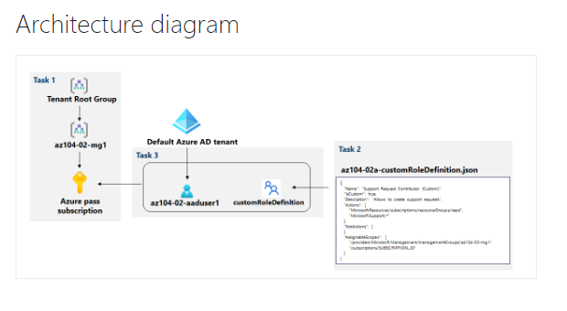

* Task 1: Implement Management Groups.
  + In this task, we will create and configure management groups. And the created group:

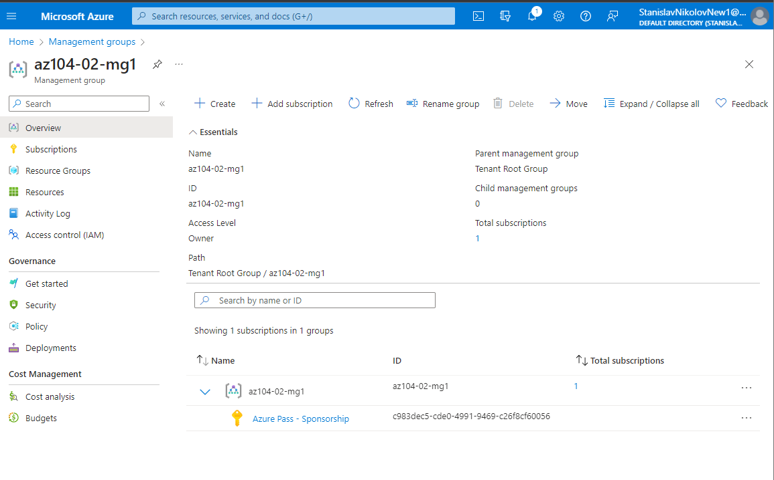

Subscription ID: c983dec5-cde0-4991-9469-c26f8cf60056

* Task 2: Create custom RBAC roles.
  + In this task, you will create a definition of a custom RBAC role.

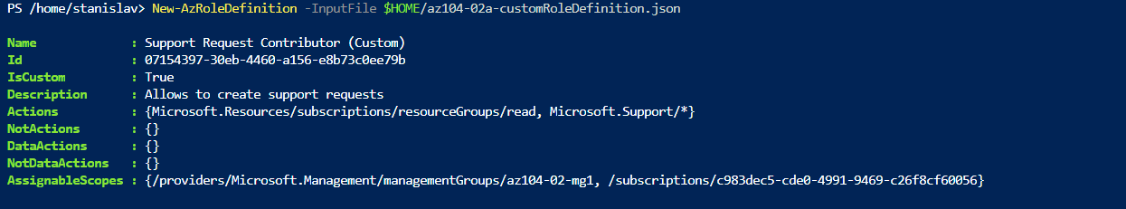

* + Replacing the SUBSCRIPTION_ID placeholder in the JSON file with the subscription ID and running the following to create the custom role definition.
* Task 3: Assign RBAC roles.
  + In this task, you will create an Azure Active Directory user, assign the RBAC role you created in the previous task to that user, and verify that the user can perform the task specified in the RBAC role definition.
  + Full username: [az104-02-aaduser1@stanislavnikolovnew1outlook.onmicrosoft.com](mailto:az104-02-aaduser1@stanislavnikolovnew1outlook.onmicrosoft.com)

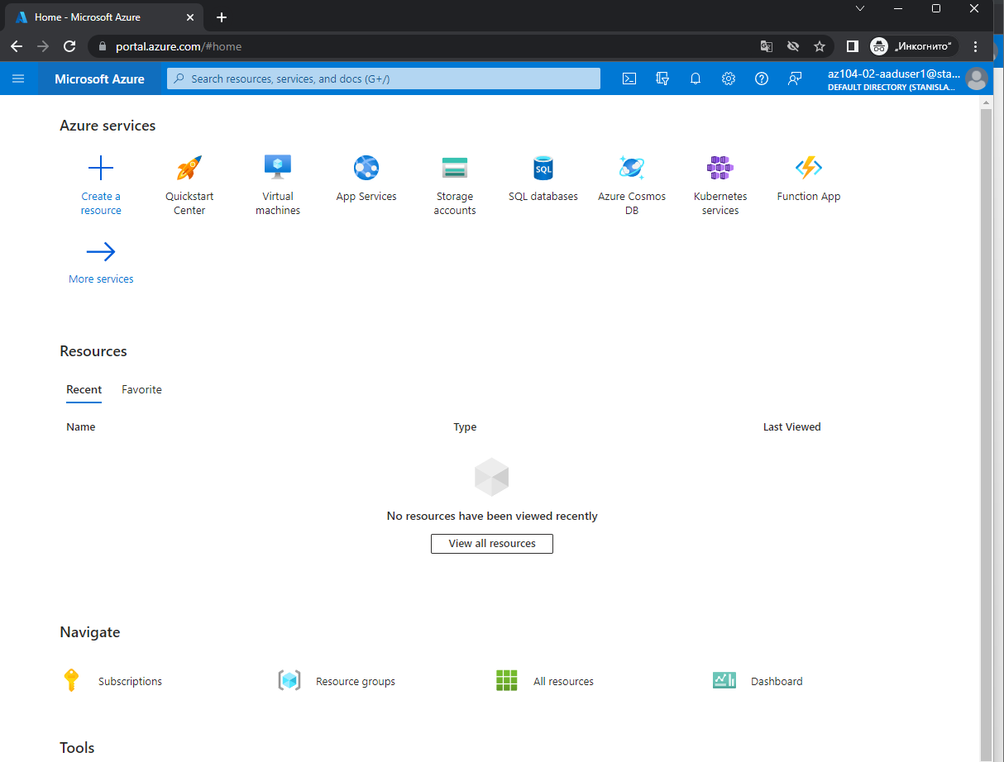

* + Opening the new user in the Private browser and logging in

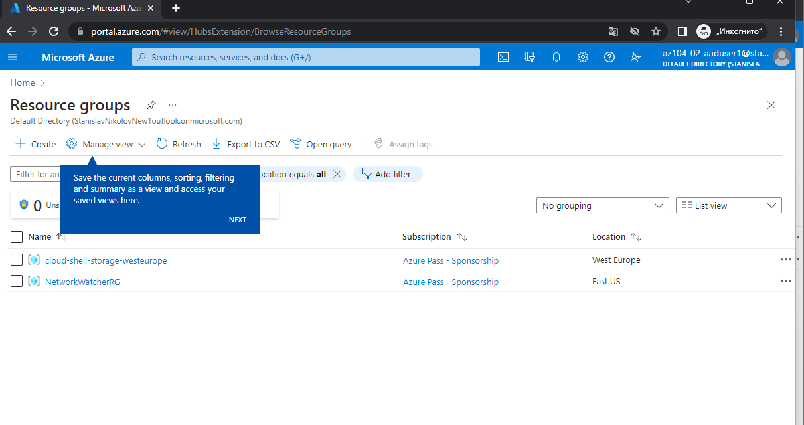

* + verifying that the az104-02-aaduser1 user can see all resource groups

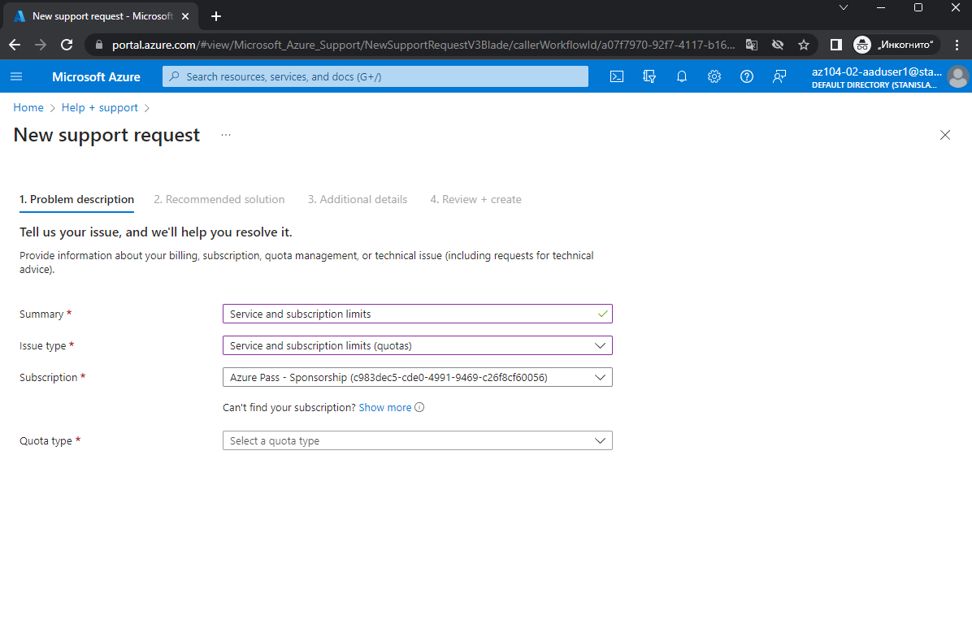

* + In the private tab, creating support request

User profile Object id: 55a4d064-f768-49f4-82f5-7fa8575f658c for cleanup